

Analytics in a Day  
Azure Synapse + Power BI better together

Exercise 07

# Optimize a Power BI Model

## Overview

The estimated time to complete this exercise is 15 minutes.

Important: It’s a prerequisite that you successfully complete Exercise 06 before commencing this exercise.

In this exercise, you are working in the role of a data architect or BI developer.

You will use Power BI Desktop to continue the development of the data model you developed in Exercise 06. The goal in this exercise is to improve query performance. You will commence by configuring dimension table storage as dual. You will then add an aggregation table to accelerate query performance. The model storage will be switched to mixed mode: Some tables will cache data to further boost query performance. You will finalize the exercise by deploying the model to the Power BI service, so it is ready for reporting in Exercise 08.

## Section 1: Add an Aggregation Table

In this section, you will configure dimension tables as dual storage mode table. You will then create an aggregation table to boost Power BI query performance for date, geography, and profit reporting.

### Task 1: Configure Dual Storage

In this task, you will configure dual storage for all dimension tables.

1. Switch to the Power BI Desktop solution you developed in Exercise 06.
2. Switch to Model view.
3. While pressing the Ctrl key, multi-select each of the five dimension tables:

* Customer
* Date
* Geography
* Product
* Salesperson

1. In the Properties pane, from within the Advanced section, in the Storage Mode dropdown list, select Dual.

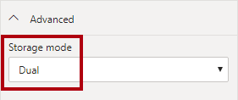

It’s common to set dimension tables to use dual storage mode. This way, when used by report slicers, they deliver fast performance.

1. When prompted to set the storage mode, click OK.

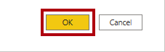

1. When the refresh completes, save the Power BI Desktop solution.

The data model is now in mixed mode. It’s a composite model consisting of DirectQuery storage mode tables and import storage mode tables.

1. In File Explorer, notice the file size has grown as a result of the imported data for the dimension tables.

When the model stores data, you need to ensure the cached data is current. The model must be refreshed on a frequent basis to ensure import data is in sync with the source data.

1. In Report view, in the status bar, at the bottom-right, notice that the storage mode is now mixed.



1. In the Performance Analyzer pane, start recording, and then refresh visuals.
2. Notice that the query result for the slicer is now sub-second.
3. In the Performance Analyzer pane, stop recording.

### Task 2: Create an Aggregation Table

In this task, you will create an aggregation table to accelerate Power BI report visuals that specifically query by date and geography, and summarize profit.

1. To open the Power Query Editor window, on the Home ribbon tab, from inside the Queries group, click the Transform Data icon.

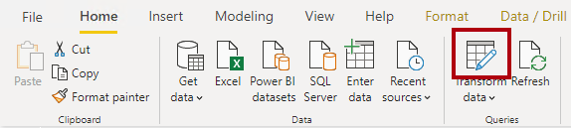

1. In the Power Query Editor window, from inside the Queries pane, right-click the Sale query, and then select Duplicate.

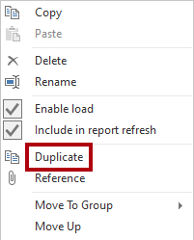

1. In the Queries pane, notice the addition of a new query.

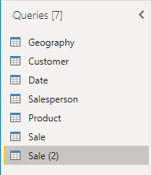

You’ll apply a transformation to group by the CityKey and InvoiceDateKey columns, and aggregate the sum of Profit Amount column.

1. Rename the query as Sale Agg.

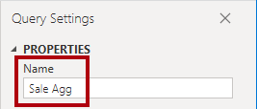

1. On the Transform ribbon tab, from inside the Table group, click Group By.

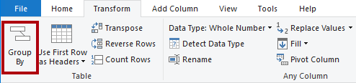

1. In the Group By window, select the Advanced option.

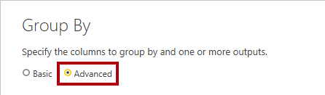

The advanced option allows grouping by more than one column.

1. In the grouping dropdown list, ensure that CityKey is selected.

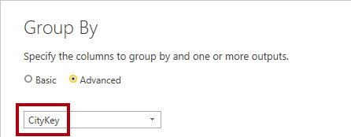

1. Click Add Grouping.
2. In the second grouping dropdown list, select InvoiceDateKey.
3. In the New Column Name box, replace the text with Profit Amount.
4. In the Operation dropdown list, select Sum.
5. In the Column dropdown list, select Profit Amount.

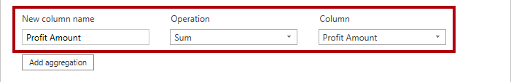

1. Click OK.

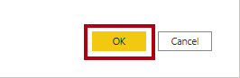

1. On the Home ribbon tab, from inside the Close group, click the Close & Apply icon.

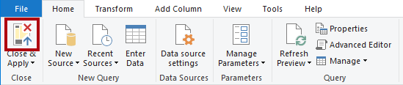

A new table is added to the model.

1. Save the Power BI Desktop solution.

### Task 3: Configure Aggregations

In this task, you will switch the aggregation table to import data. You will then create model relationships to the aggregation table and manage aggregations.

1. Switch to Model view.
2. Position the Sale Agg table so that it is near the Geography and Date tables.
3. Set the storage mode for the Sale Agg table as Import.

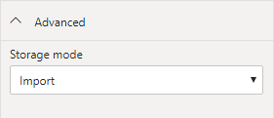

1. Create two model relationships:

* Relate the Sale Agg table CityKey column to the Geography table CityKey column
* Relate the Sale Agg table InvoiceDateKey column to the Date table Date column

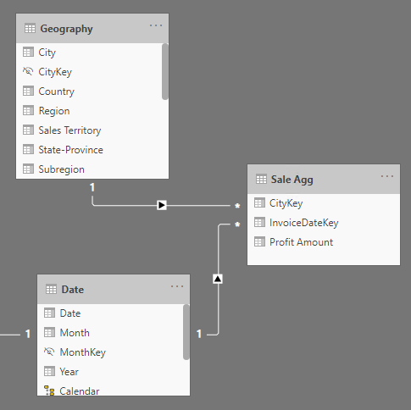

1. Right-click the Sale Agg table, and then select Manage Aggregations.

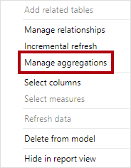

1. In the Manage Aggregations window, for the Profit Amount aggregation column, set the following properties:

* Summarization: Sum
* Detail table: Sale
* Detail column: Profit Amount

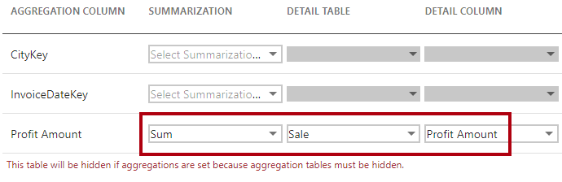

1. Notice the warning that describes the table will be hidden.

The table will be hidden in a different way to other hidden model objects (like the key columns you hid in Exercise 06). Aggregation tables are always hidden, and they can’t even be referenced in model calculations.

1. Click Apply All.



1. In the model diagram, notice that the Sale Agg table is now hidden.

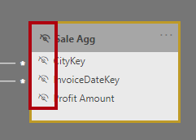

1. In the model diagram, select the Sale Agg table.
2. Switch to Report view.
3. In the Performance Analyzer pane, start recording, and then refresh visuals.
4. Notice that the query results for the table visual is now sub-second.

Because the Geography and Date tables use dual storage mode, when a report visual queries them at the same time as the aggregation table, Power BI will query the model cache. There’s no need to use DirectQuery to query the data.

1. In the Performance Analyzer pane, stop recording.

## Section 2: Publish the Model

In this section, you will publish the model and complete some post-publication tasks.

### Task 1: Publish the Model

In this task, you will publish the model.

1. In Power BI Desktop, on the Home ribbon tab, from inside the Share group, click Publish.

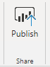

1. If prompted to save changes, click Yes.
2. In the Publish to Power BI window, select the lab workspace (do not use My Workspace).
3. Click Select.

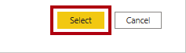

1. When publication has completed, click Got It.
2. Close Power BI Desktop.

You will open a new instance of Power BI Desktop in Exercise 08 when you create a report.

### Task 2: Complete Post-Publication Tasks

In this task, you will complete some post-publication tasks.

You’ll complete the post-publication tasks using the Power BI service because it’s not possible to do them in Synapse Studio.

1. In the Power BI web browser session, open your lab workspace.

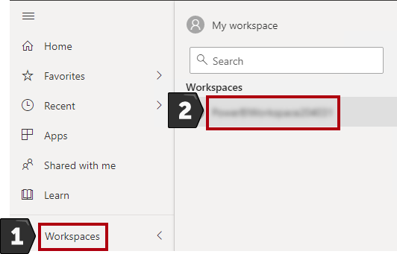

1. In the Navigation pane (located at the left), expand the workspace, and then verify that the Sale Analysis dataset exists.

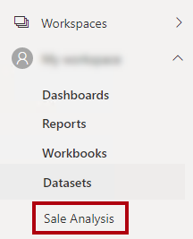

1. Notice there is also the Sale Analysis report.

It wasn’t our intention to publish a report, it was published alongside the model. You’ll develop a report in Exercise 08. So, we’ll delete this report.

1. In the Navigation pane, hover the cursor over the Sale Analysis report, click the vertical ellipsis (…), and then select Remove.

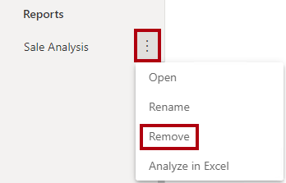

1. When prompted to delete the report, click Delete.

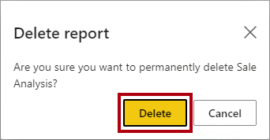

1. To apply data source credentials, in the Navigation pane, hover the cursor over the Sale Analysis dataset, click the vertical ellipsis, and then select Settings.

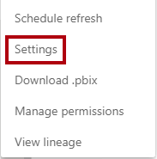

1. Expand the Data Source Credentials section.

You’ll see an error, and it’s expected. You will address the error in the next step.

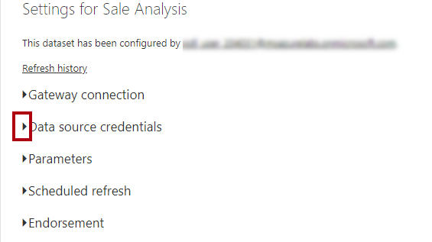

1. To assign credentials, click the Edit Credentials link.
2. In the window, in the Authentication Method dropdown list, ensure that Microsoft Account is selected.
3. In the Privacy Level dropdown list, select Organizational.

If you need the Power BI report user identity to flow to Azure Synapse (because per-user access permission must be enforced), you can check the checkbox. When the checkbox is left unchecked, the identity you will use to sign in (at the next step) will be used for all connections.

1. Click Sign In.

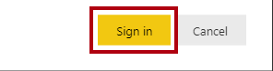

1. Use the lab Azure credentials to sign in.
2. Expand the Scheduled Refresh section.

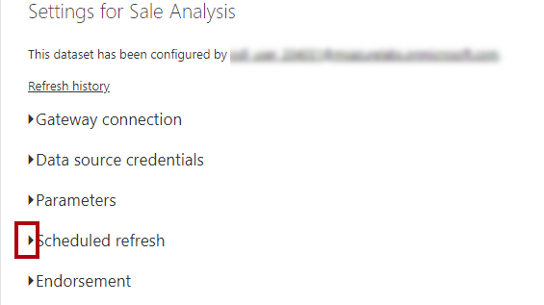

In this exercise, you won’t schedule data refresh because it’s a lab. In the real world, because your dataset contains import data (for the dimension tables and the aggregation table), you would schedule data refresh to keep the aggregation and dimension table import data current. It’s possible, too, that your Azure Data Factory pipelines could send refresh commands using the Power BI REST API, once the data warehouse load has completed.

1. Expand the Endorsement section.

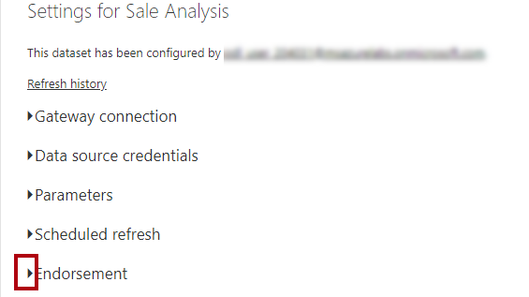

1. Select the Promoted option.

The promoted endorsement communicates that the model is production-ready. In this exercise, ideally, you’d select the Certified option. A certified dataset is one that’s truly reliable and authoritative, designed for use across the organization. (It’s not available for your trial account.)

1. In the Description box, enter: Lab dataset
2. Click Apply.



1. Switch to the Azure Synapse web browser session.
2. In the Develop hub, select Power BI Datasets.
3. Notice that the Sale Analysis dataset is listed.

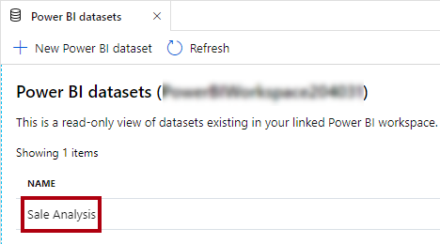

The dataset is published and is configured ready for use. In Exercise 08, you’ll perform a live connection to the dataset and create a report.

## Summary

In this exercise, you used Power BI Desktop to configure dimension table storage as dual. You then added an aggregation table to accelerate query performance. The model storage was switched to mixed mode: Some tables now cache data to further boost query performance. You finalized the exercise by deploying the model to the Power BI service, so it is ready for reporting in Exercise 08.

## Terms of Use

© 2020 Microsoft. All rights reserved.

By using this hands-on lab, you agree to the following terms:

The technology/functionality described in this hands-on lab is provided by Microsoft Corporation in a “sandbox” testing environment for purposes of obtaining your feedback and to provide you with a learning experience. You may only use the hands-on lab to evaluate such technology features and functionality and provide feedback to Microsoft. You may not use it for any other purpose. Without written permission, you may not modify, copy, distribute, transmit, display, perform, reproduce, publish, license, create derivative works from, transfer, or sell this hands-on lab or any portion thereof.

COPYING OR REPRODUCTION OF THE HANDS-ON LAB (OR ANY PORTION OF IT) TO ANY OTHER SERVER OR LOCATION FOR FURTHER REPRODUCTION OR REDISTRIBUTION WITHOUT WRITTEN PERMISSION IS EXPRESSLY PROHIBITED.

THIS HANDS-ON LAB PROVIDES CERTAIN SOFTWARE TECHNOLOGY/PRODUCT FEATURES AND FUNCTIONALITY, INCLUDING POTENTIAL NEW FEATURES AND CONCEPTS, IN A SIMULATED ENVIRONMENT WITHOUT COMPLEX SET-UP OR INSTALLATION FOR THE PURPOSE DESCRIBED ABOVE. THE TECHNOLOGY/CONCEPTS REPRESENTED IN THIS HANDS-ON LAB MAY NOT REPRESENT FULL FEATURE FUNCTIONALITY AND MAY NOT WORK THE WAY A FINAL VERSION MAY WORK. WE ALSO MAY NOT RELEASE A FINAL VERSION OF SUCH FEATURES OR CONCEPTS. YOUR EXPERIENCE WITH USING SUCH FEATURES AND FUNCITONALITY IN A PHYSICAL ENVIRONMENT MAY ALSO BE DIFFERENT.

FEEDBACK If you give feedback about the technology features, functionality and/or concepts described in this hands-on lab to Microsoft, you give to Microsoft, without charge, the right to use, share and commercialize your feedback in any way and for any purpose. You also give to third parties, without charge, any patent rights needed for their products, technologies and services to use or interface with any specific parts of a Microsoft software or service that includes the feedback. You will not give feedback that is subject to a license that requires Microsoft to license its software or documentation to third parties because we include your feedback in them. These rights survive this agreement.

MICROSOFT CORPORATION HEREBY DISCLAIMS ALL WARRANTIES AND CONDITIONS WITH REGARD TO THE HANDS-ON LAB, INCLUDING ALL WARRANTIES AND CONDITIONS OF MERCHANTABILITY, WHETHER EXPRESS, IMPLIED OR STATUTORY, FITNESS FOR A PARTICULAR PURPOSE, TITLE AND NON-INFRINGEMENT. MICROSOFT DOES NOT MAKE ANY ASSURANCES OR REPRESENTATIONS WITH REGARD TO THE ACCURACY OF THE RESULTS, OUTPUT THAT DERIVES FROM USE OF THE VIRTUAL LAB, OR SUITABILITY OF THE INFORMATION CONTAINED IN THE VIRTUAL LAB FOR ANY PURPOSE.

DISCLAIMER This lab contains only a portion of new features and enhancements in Microsoft Power BI. Some of the features might change in future releases of the product.